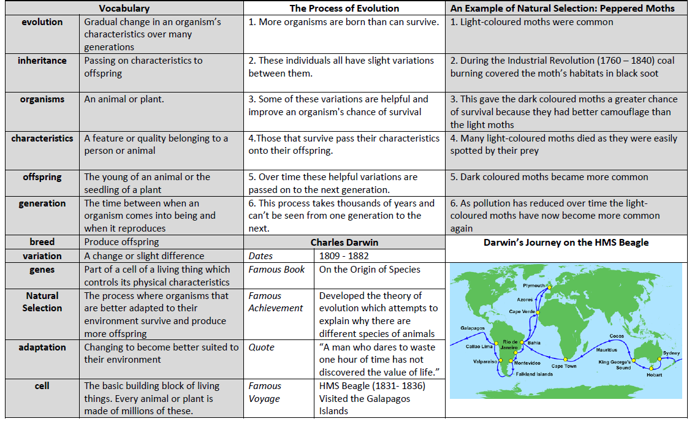
What happened when Charles Darwin visited the Galapagos Islands? Evolution and Inheritance Knowledge Organiser

